3 – Git-HOL Hands-On
Branching
Step1: Creating the new branch
Step 2: Listing all branches
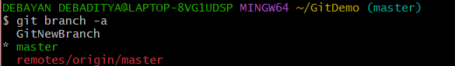
Step 3: Switching the branch and adding a file
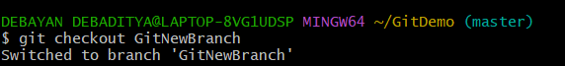
Step 4: Create a new file with some text inside it –
Step 5: Stage, Commit and Check Status
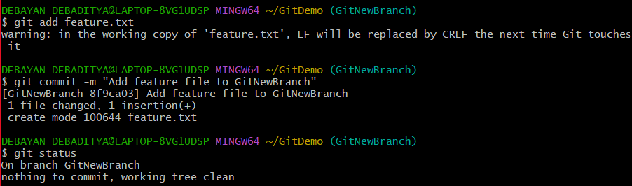
Merging
Step 1: Switching back to master
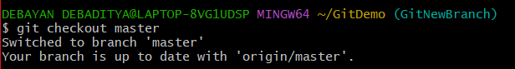

Step 2: Listing the command-line differences
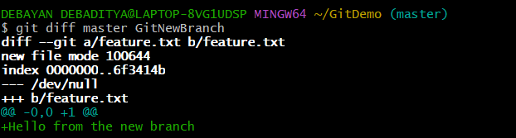
Step 3: Listing the visual differences using P4Merge
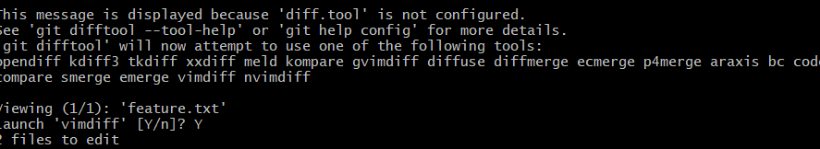
Step 4: Merging the branch into master
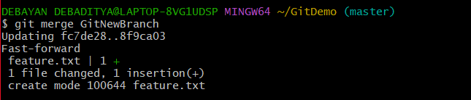
Step 5: Observing the visual history graph
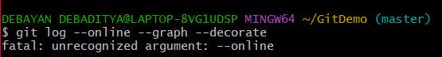
Step 6: Deleting the source branch
